NCC Activity Session 2020-21

- 06.05.20. Awareness about Covid- 19 from Poster making, making videos, distributed masks and sanitizes around village and local places.
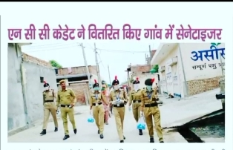
- 21.06.20. Organized “International Yoga Day” and participated NCC SW Cadets of GCW, Karnal.

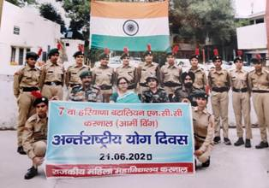
- 10.07.20. Training Camp about EBSB (Ek Bharat Shresth Bharat) and got certificates by NCC Cadets.
- 21.07.20. Organized “Road Safety Online Webinar”. Main speakers were Deepa arora Ma’am, Capt. Anita Joon, And Sapna Ma’am.

- 08.08.20. Cadets who have taken pledge on website (http//pledge.my.gov.in/vocal about local).

- 15.08.2020. Fit India Youth Club Programme was organized.

- 05.09.20. Celebrated Teacher’s Day through online webinar. Regarding New Education policy.

- 28.10.20. Digital forum for sharing details by 7 HR BN NCC, registration by NCC cadets with different activities. Tree plantation, Jal shakti, Atmanirbhar Bharat, Vijay diwas, Fit India, green India, Sports and Adventure Activity.

- 23.12.20. Cleanliness drive was conducted in the college campus by NCC cadets.

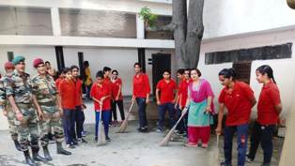

- 03.02.21-07.02.21. CATC Camp attended by 36 cadets of NCC “C” certificate in Govt. P.G. College, Sect-14, Karnal.

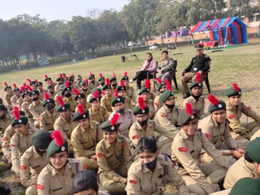

- 08.02.21-10.02.21. CATC Camp attended by 27 Cadets of “B” certificate in Govt. P.G. College, Karnal.

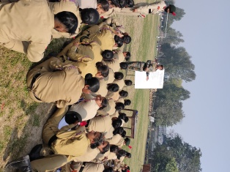

- 07.03.21. 35 Cadets were given the NCC “C” Certificate in S.D.College, Ambala.

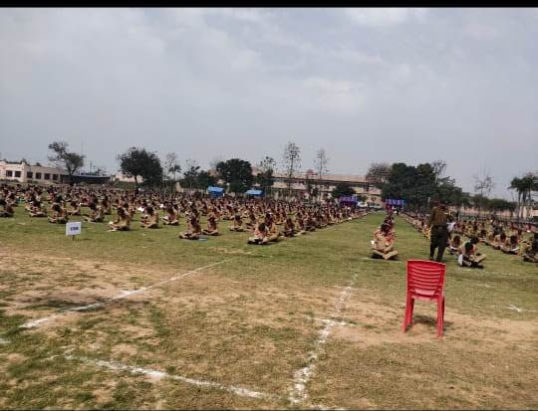

- 14.03.21. 22 cadets were given the NCC “B” certificate in G.N. Khalsa College, Karnal.

