2019-2020
- NCC Cadet GCW (Karnal), student Shivani attended Best Cadet Camp, which was organized from 15.07.19, to 20.07.19, at Ropar.
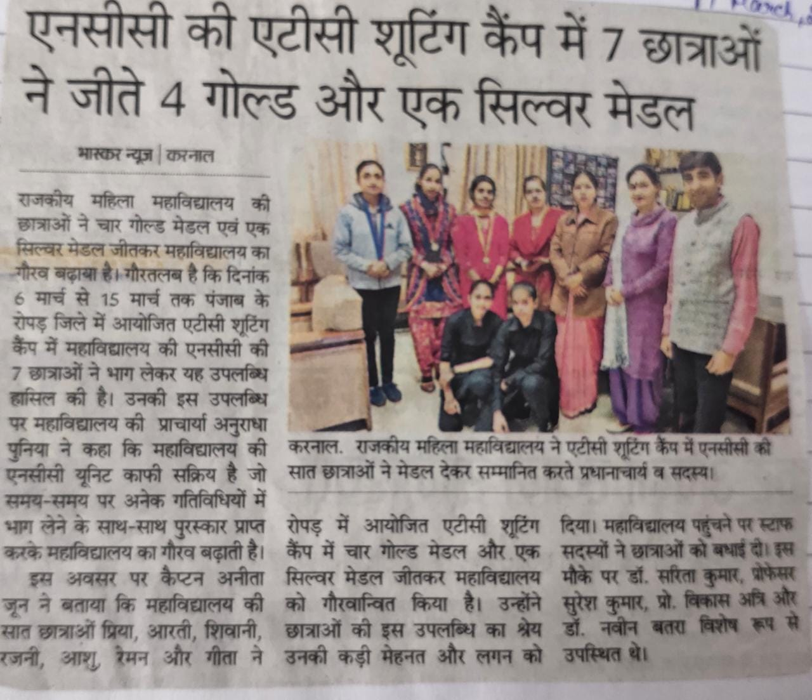
- Five NCC cadets of GCW (Karnal), participated in
“Cultural Programme” organized in Ropar Camp.
- “B” Certificate Exam was held on 23.02.20. In which NCC Girl Cadets of the college took the exam. Number – 35.
- 5 NCC Cadets participated in NIC Amritsar Camp. In which 4 Medals, Haryanvi Dance, fashion show and certificate obtained from 04.06.19 to 15.06.19.
- 4 NCC Cadet participated in BLC Malout (Punjab) till (16-27) August. Cadet Kajal got silver medal in “Tug of War” and cadet Dikshita got 2nd medal in “Guard Drill”. From 16.08.19 to 27.08.19.

