NCC Activity 2022-2023.docxNCC Activity 2021-22
- Date: 20.05.2021 Road Safety Webinar
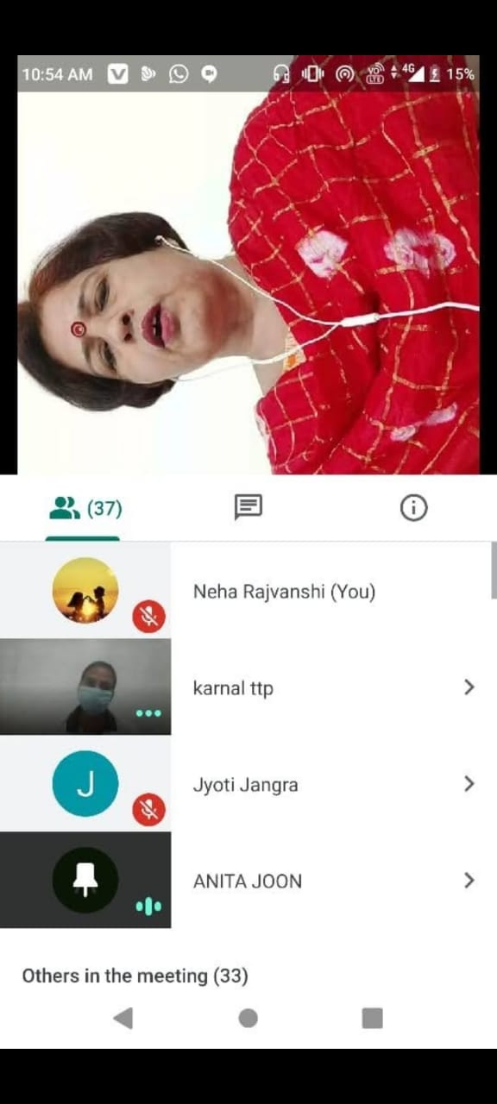

2. Date: 21.6.21 International Yoga day

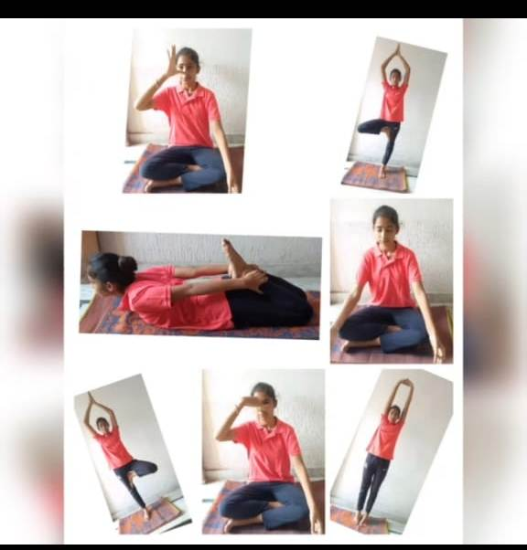

3. Date: 26.07.2021 Kargil Diwas (Nukkar Natak ) “Remember the sacrifice:
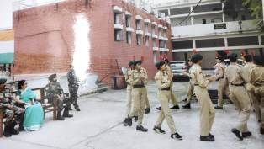
4. Date: 12.08.2021 Teej Festival

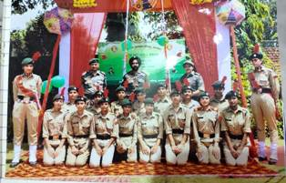

5. Date: 15.08.21 Independence day Parade (NDRI)

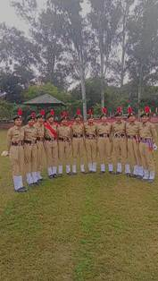

6. Date: 4.09.21 Fit India Rellay

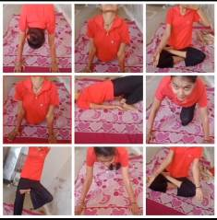

7. Date: 04.10.2021 Tree Plantation in College Ground

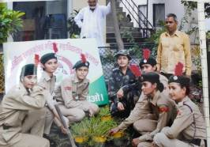

8. Date: 22.10.21- 22.12.21 NCC CATC ‘C’ Certificate camp “Winners in games and drill”
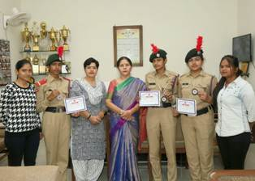

9. Date: 8.11.2021-12.11.2021 NCC CATC ‘B’ Camp in Govt P.G. College

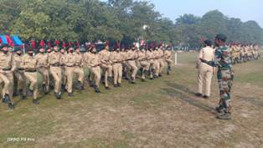

10. Date: 16.11.2021 Golden Jubilee Celebration in Mangal Sen Bhawan

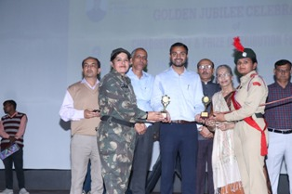

11. Date: Celebrating NCC Day

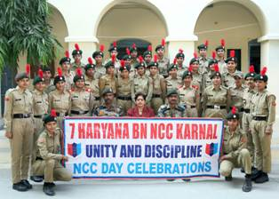

12. Date: 10.12.21 Human Rights Day

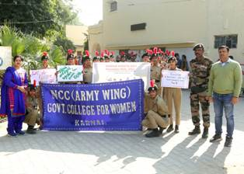

13 Date:.21.12.21 – 22.12.21 Piloting in College Athlete Meet

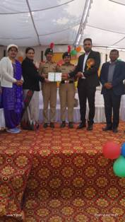

14. Date: 26.01.22 Republic Day Prade

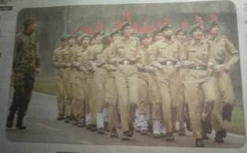

15. Date: 14.02.2022 Water Conservation Rally

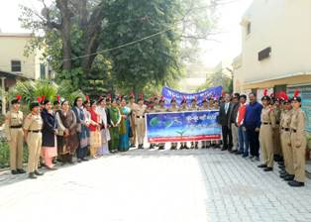

16. Date: 18.02.2022 Female Feticide Rally

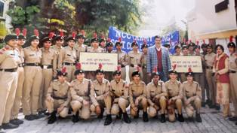

17. Date: 27.02.2022 NCC “C” Certificate exam in Ambala
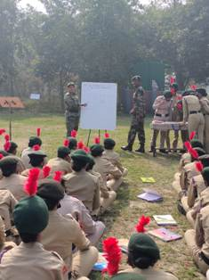

18. Date: 06.03.2022 NCC “B” Certificate exam in GN Khalsa College

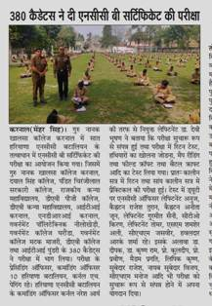

19. Date: 08.03.2022 International Women’s Day
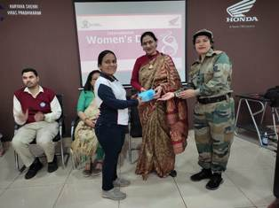

20. Date: 21.03.2022 Celebrated Nadi Utsav Programme at Karan Lake , Karnal

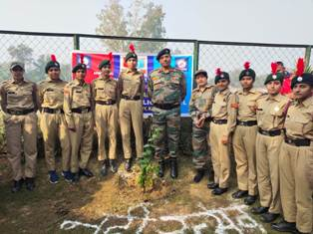

21. Date: 23.03.2022 From Karan Park to Railway Road , Flag March (Martyr’s Day)

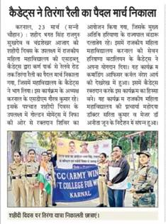

22. Date: 23.03.2022 Blood Donation Camp

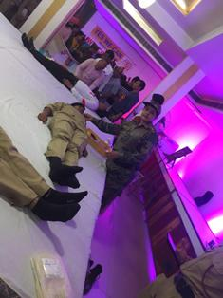

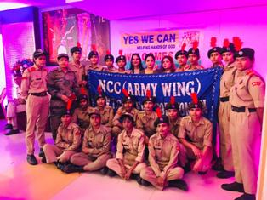

23. Date: 05.04.2022 Puneet Sagar Abhiyan (Karan Lake)

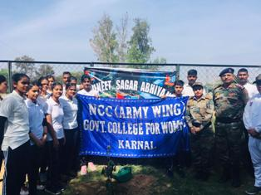

24. Date: 13.04.2022 Dr. B.R. Ambedkar Jayanti

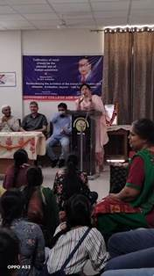
25. Date: 19.05.2022 Paryavaran Sanrakshan
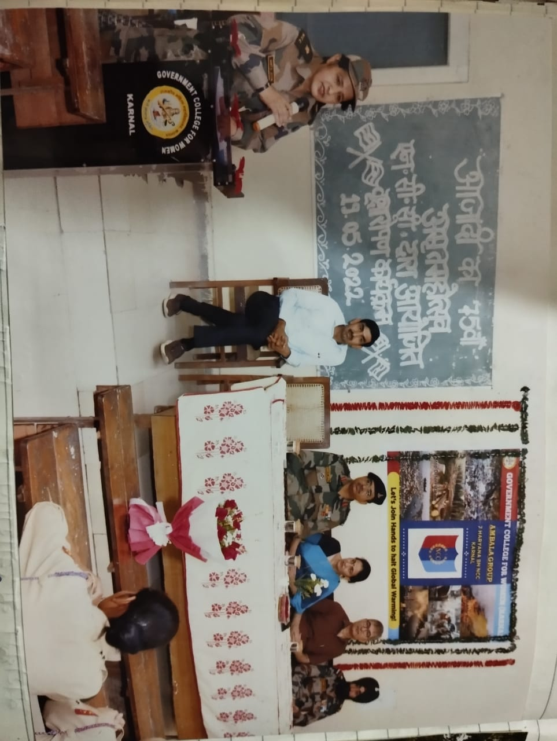

26. Date: 25.07.2022 Tree Plantation
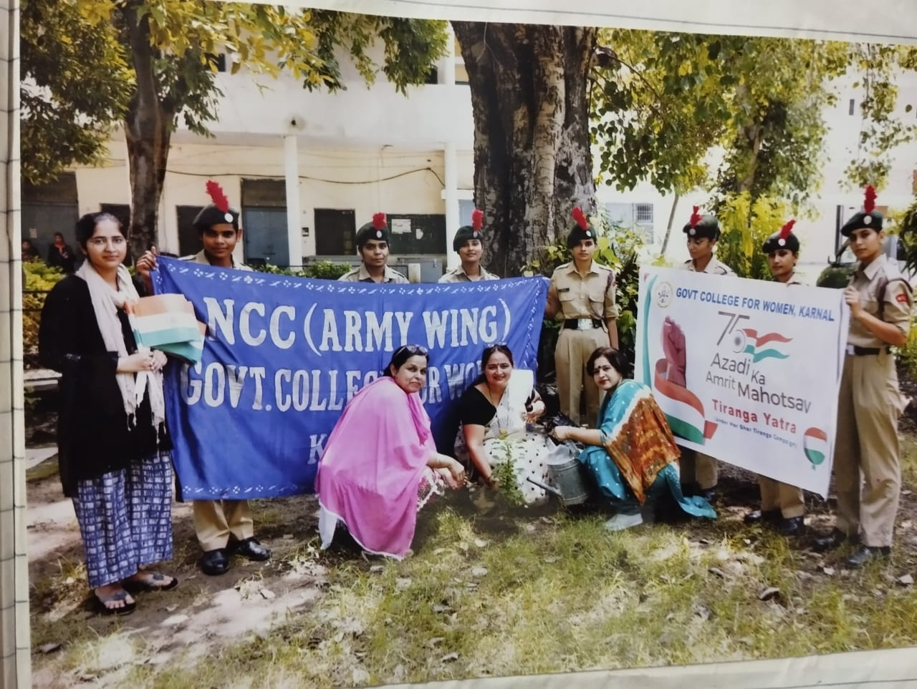

27. Date: 09.08.2022 Ralley Day

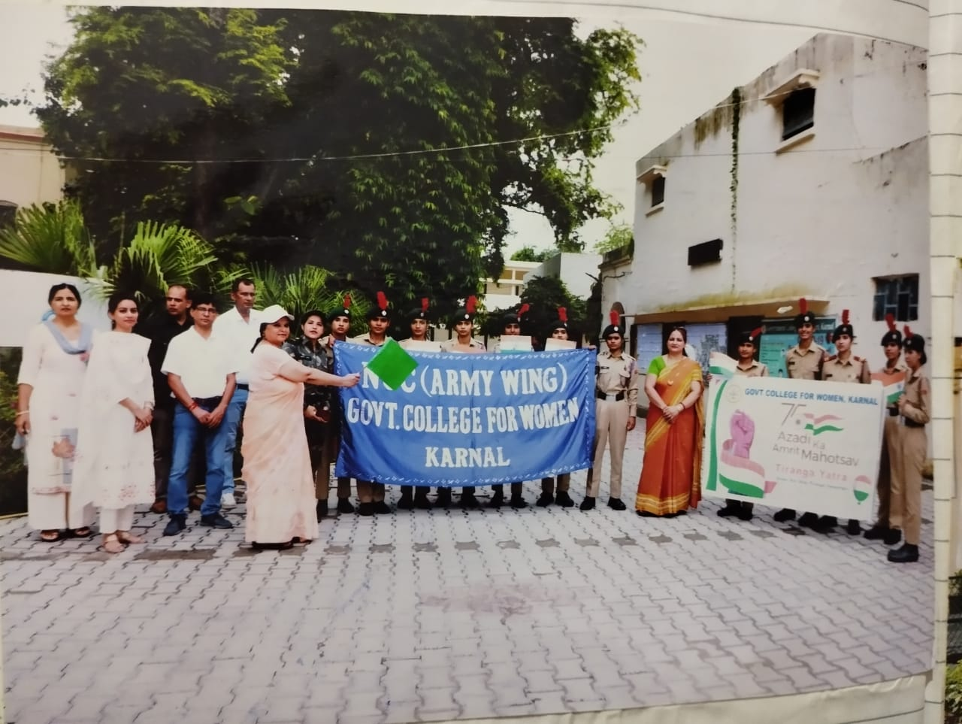
28. Date: 10.08.2022 Podha Ropan
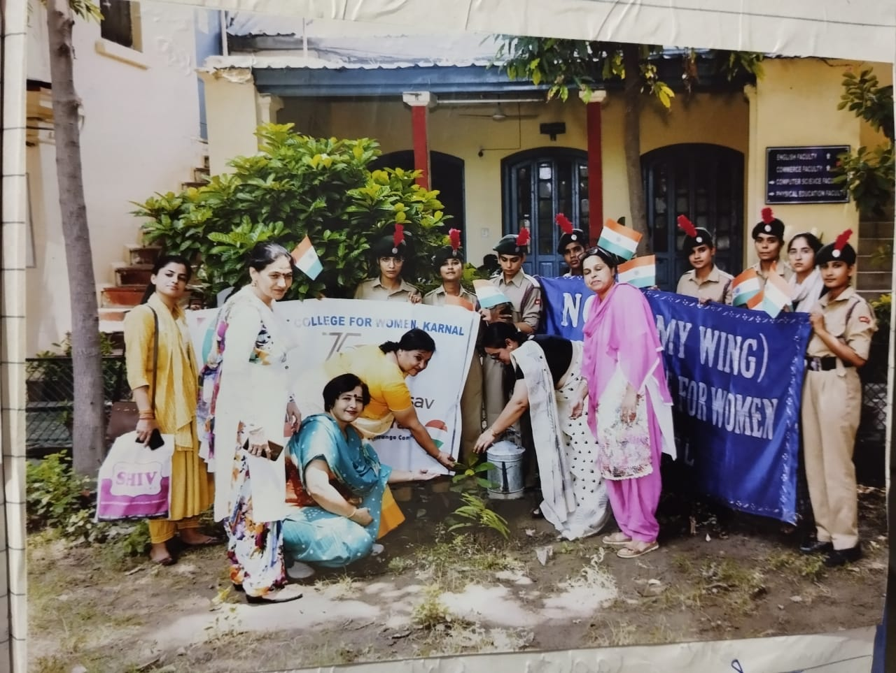

29. Date: 15.08.2022 Independence Day
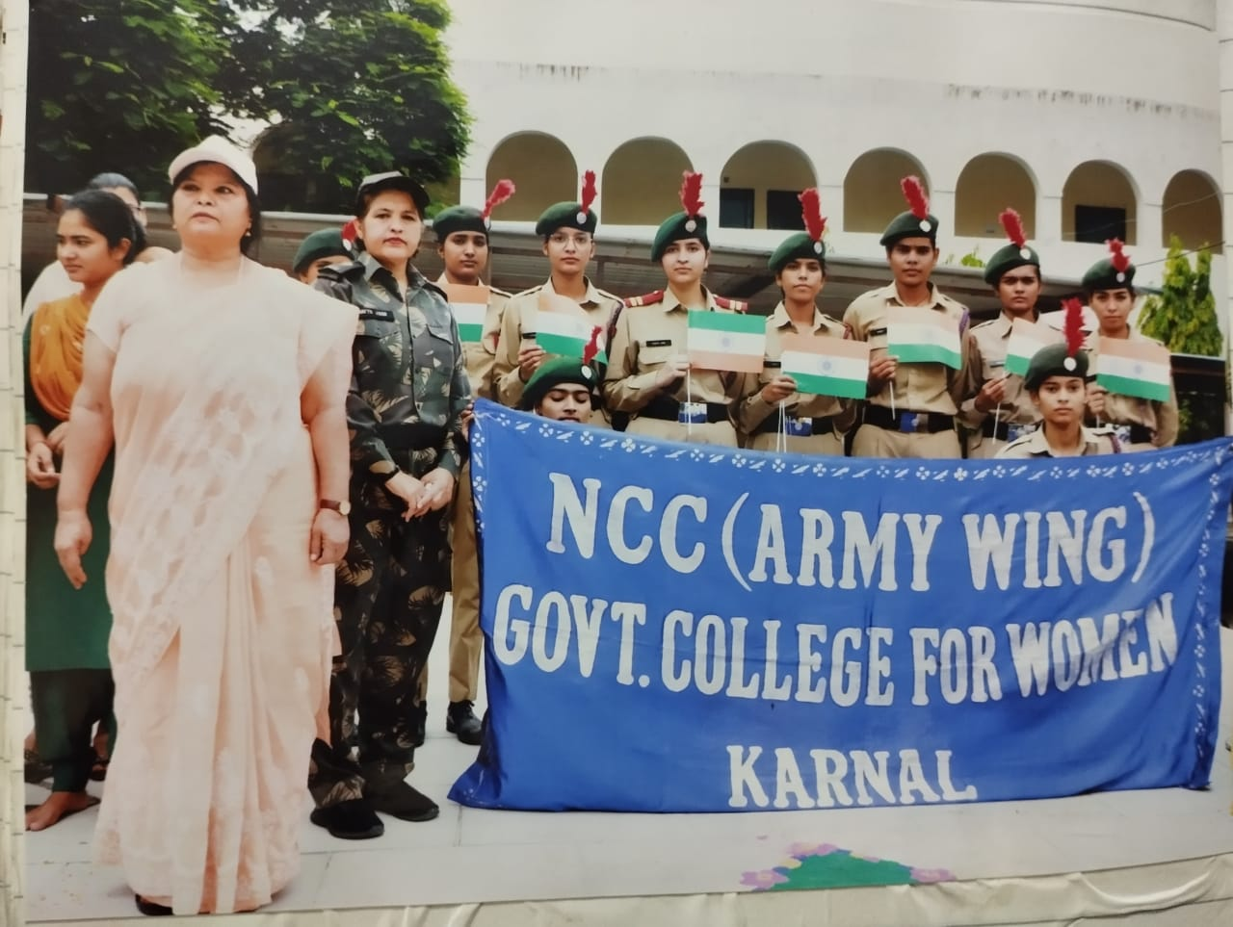
30. Date: 07.09.2022 Samuhik Nritya
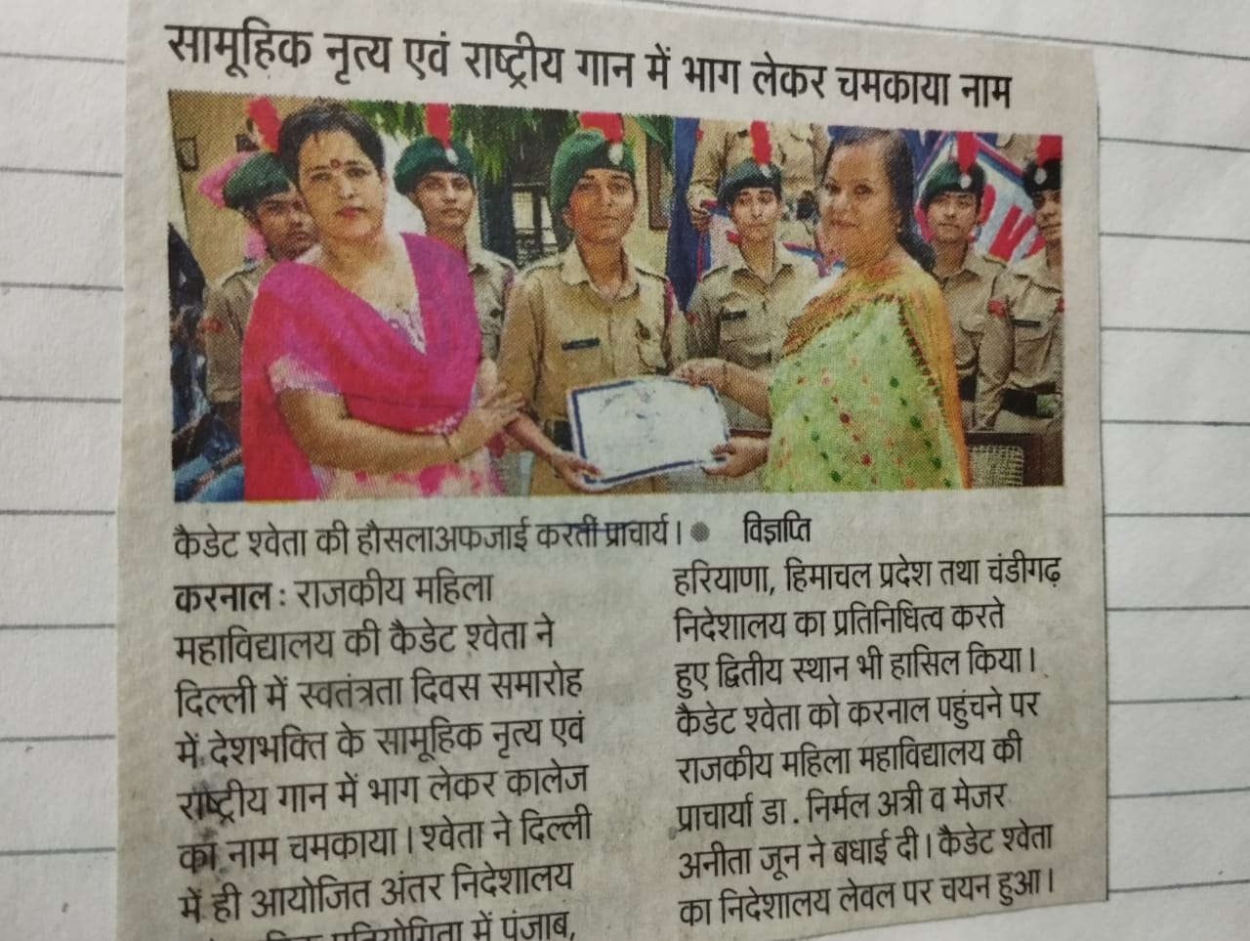
31. Date: 28.09.2022 Puneet Sagar Abhiyan
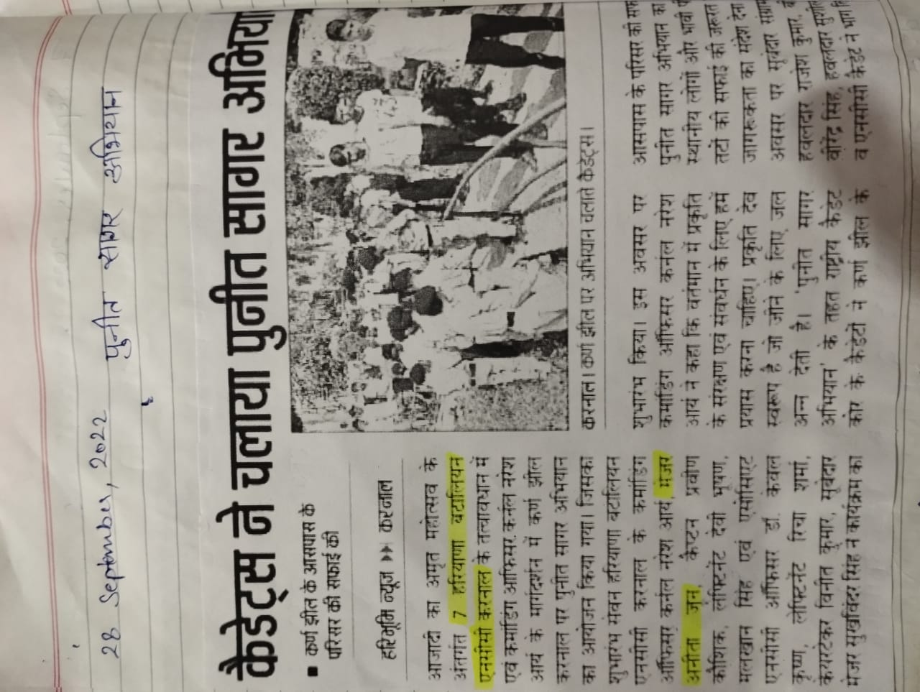
32. Date: 31.10.2022 National Unity Day
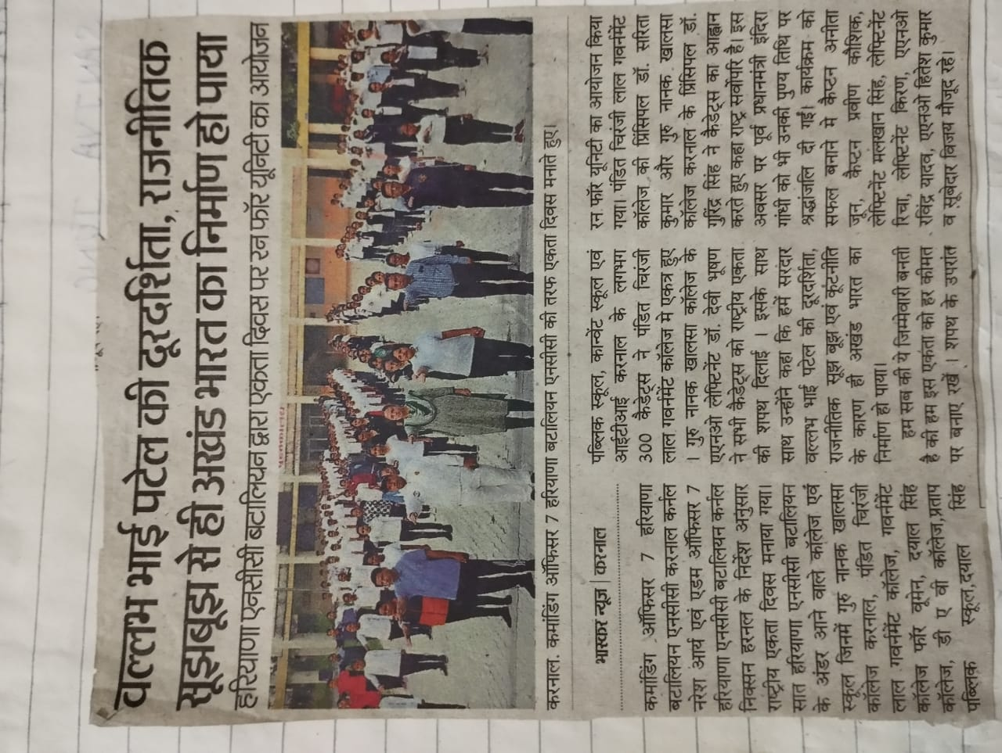
33. Date: 05.11.2022 All India Girls Trekking Camp
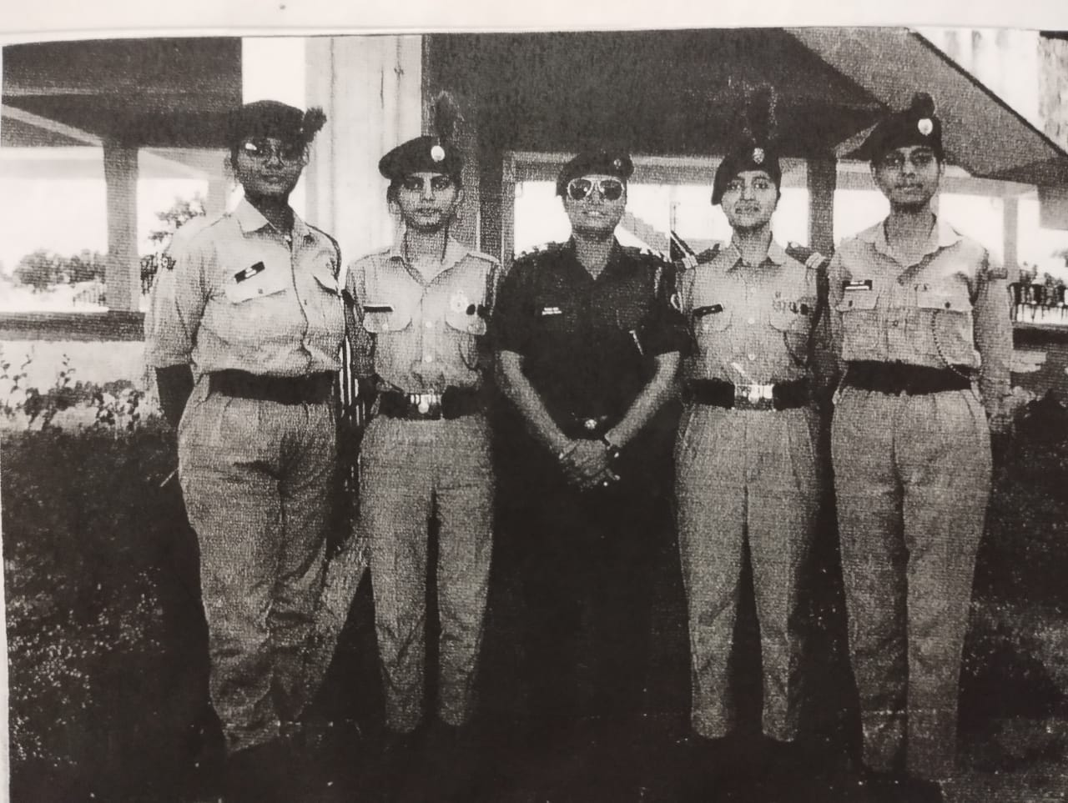
34. Date: 11.11.2022 CATC-146 At Doon Valley College Karnal
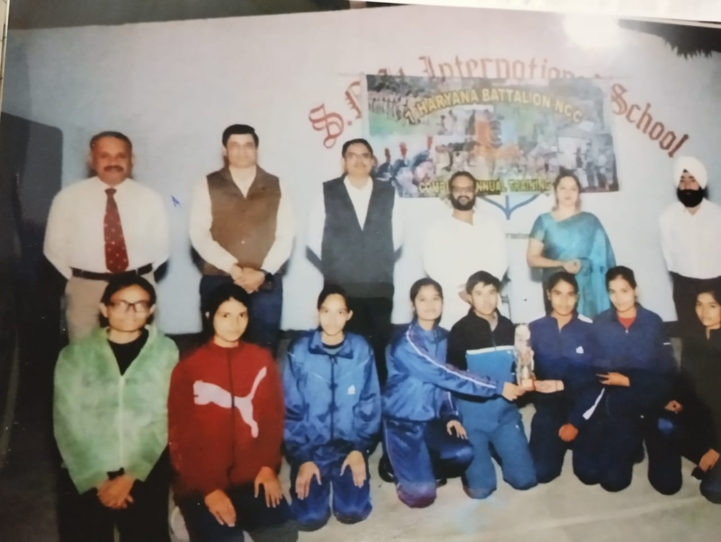
35. Date: 25.11.2022 NCC Day Celebration
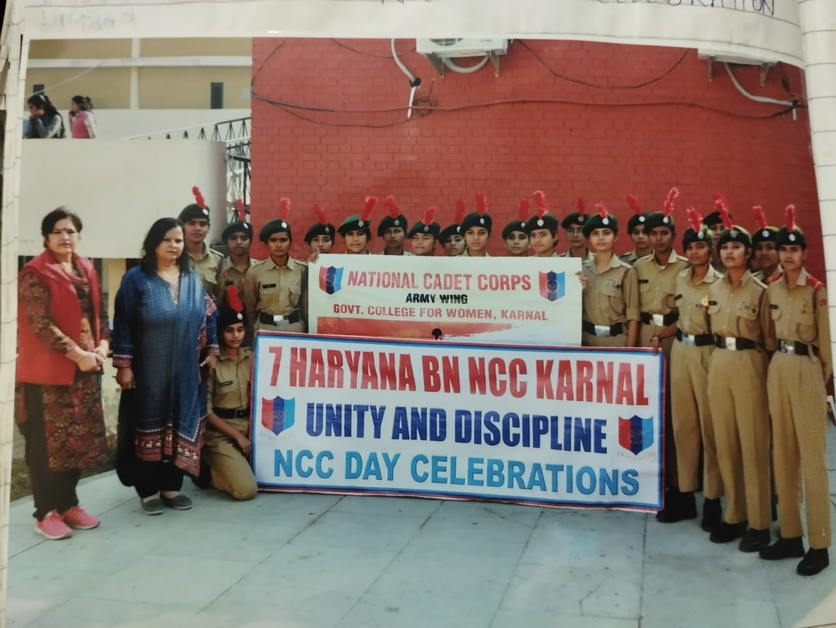
36. Date: 20.06.2023 CATC-146 At JNV, Sagga (Karnal)

37. Date: 01.09.2023 Drugs Free Haryana( cyclothon )
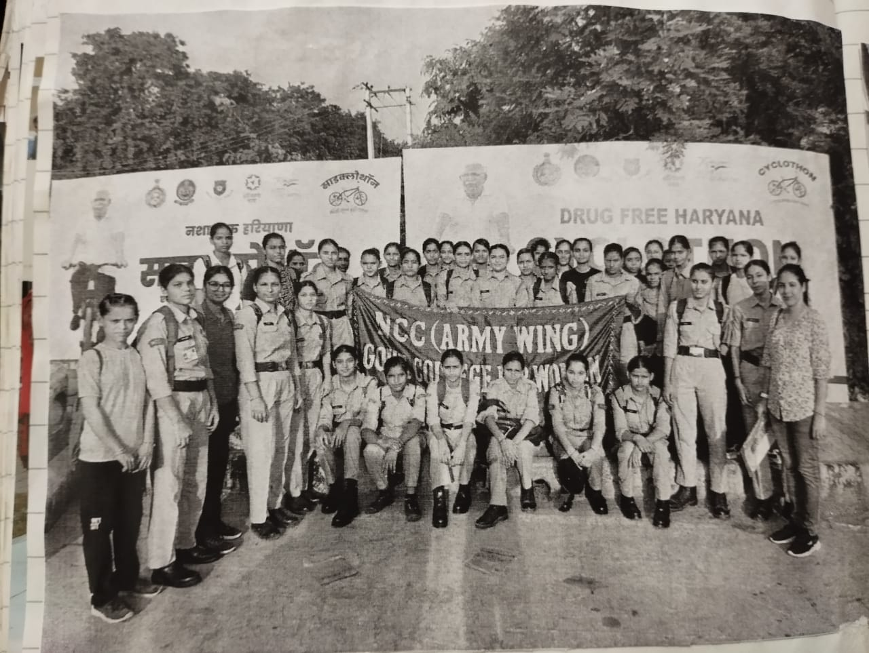
38. Date: 09.09.2023 Save Water Save Earth
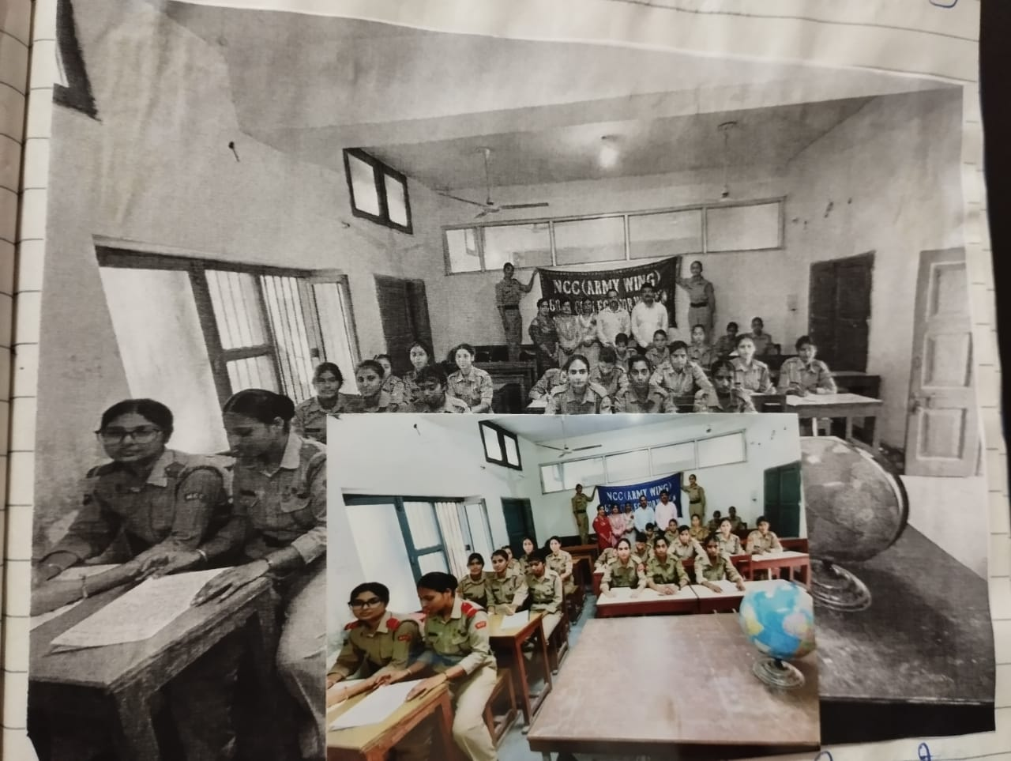
39. Date: 10.09.2023 Puneet Sagar Abhiyan
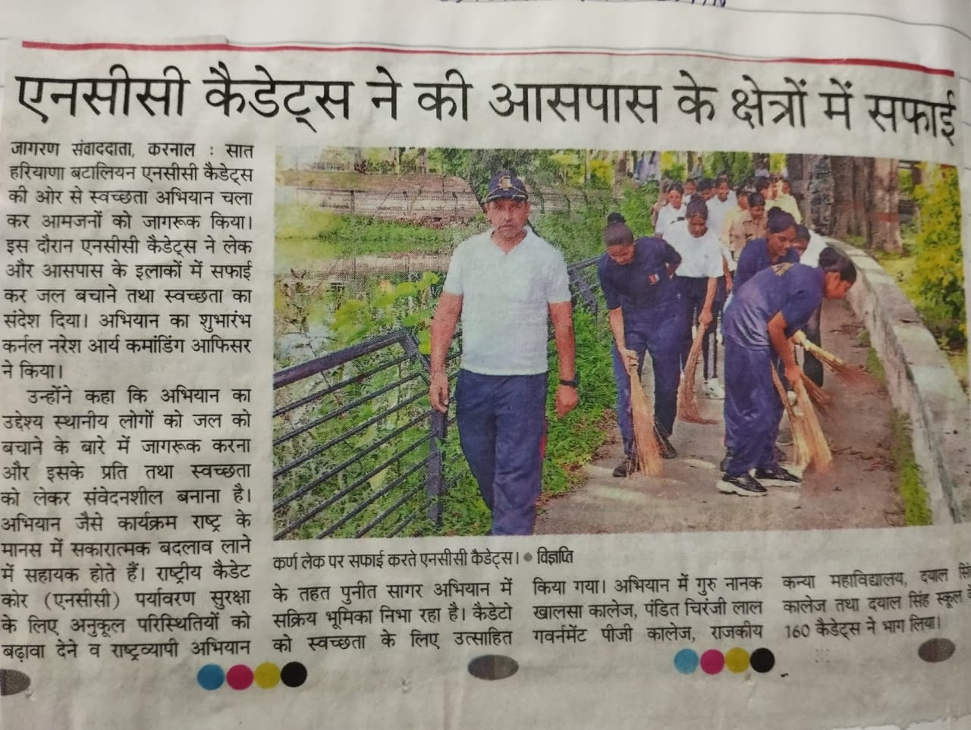
40. Date: 25.09.2023 Drug Free Haryana
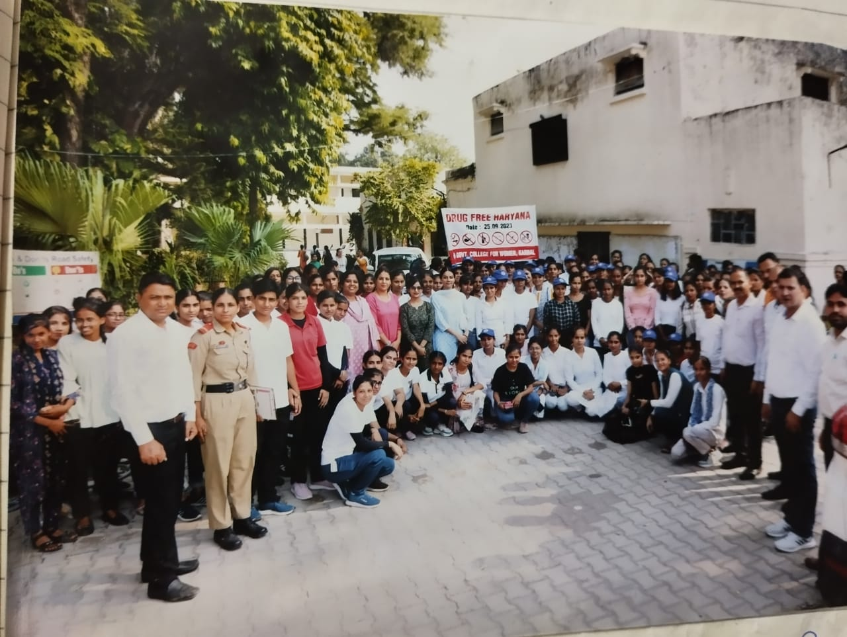
41. Date: 27.09.2023 Nukkad Natak
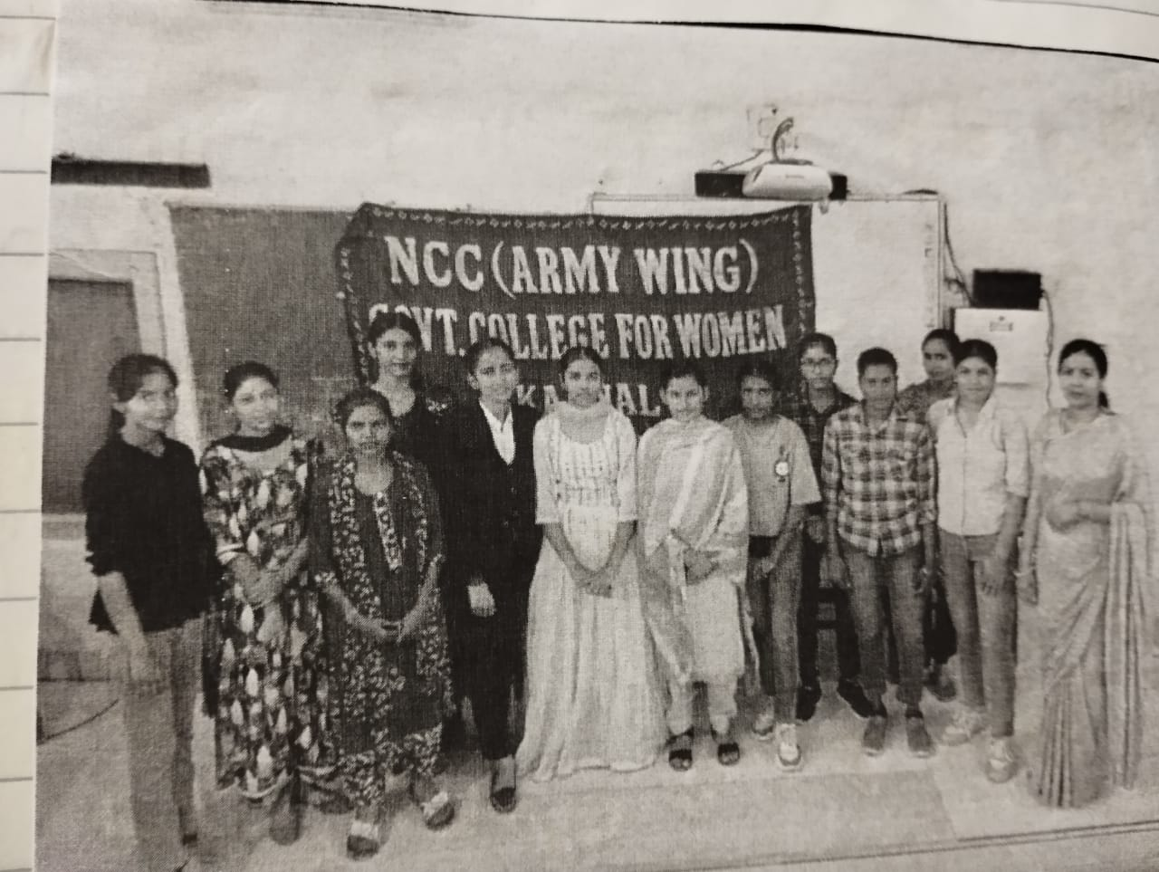
42. Date: 26.09.2023 Swachhata Pakhavaada
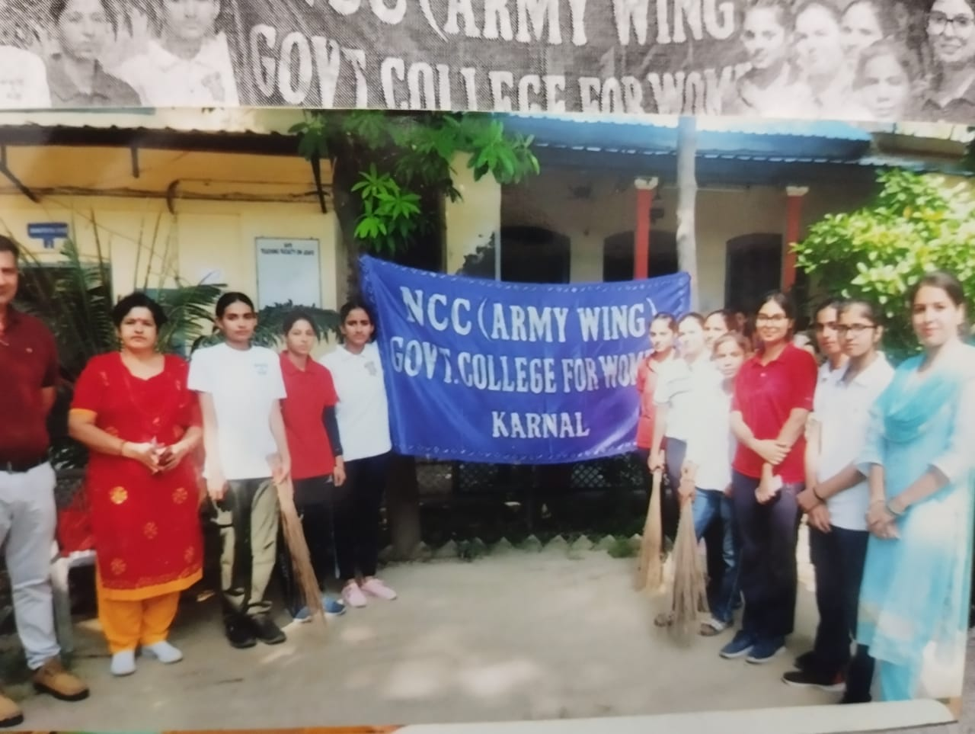
43. Date: 31.10.2023 National Unity Day
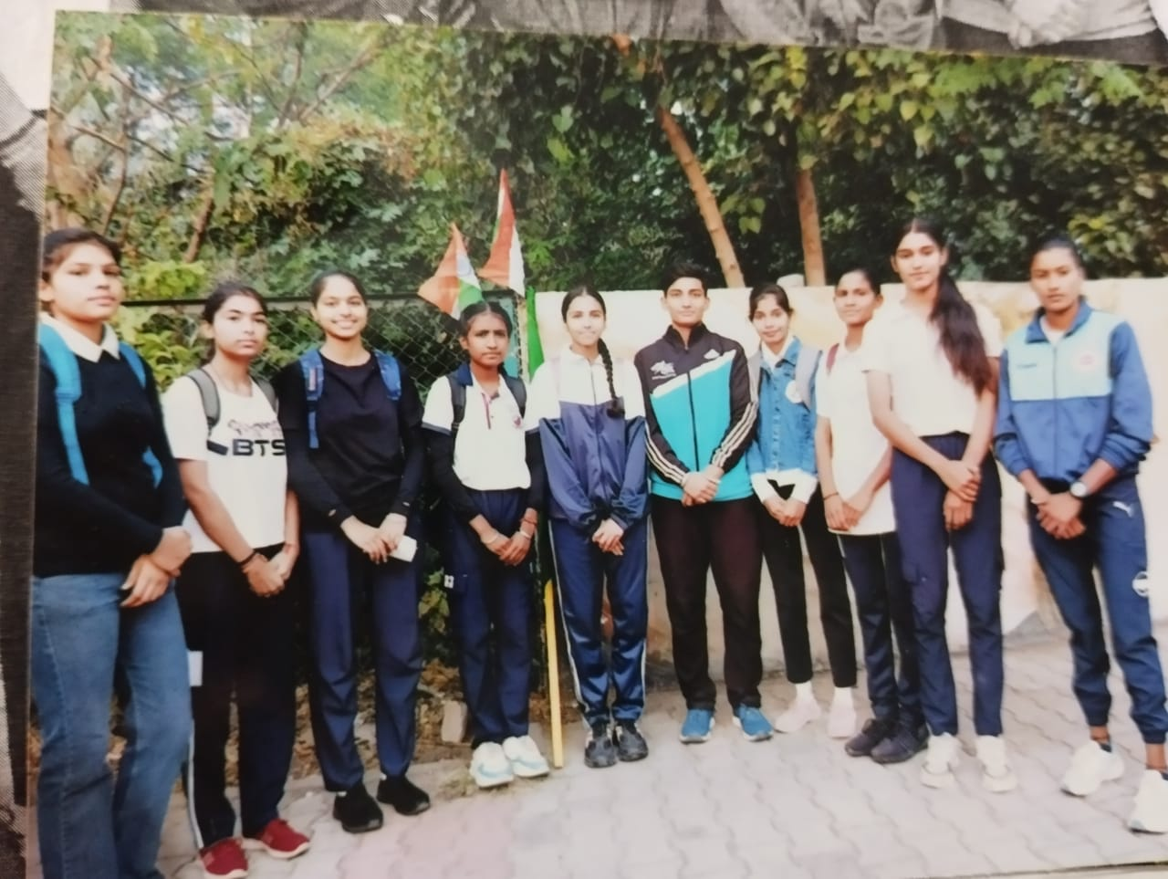
44. Date: 21.11.2023 Annual Meet
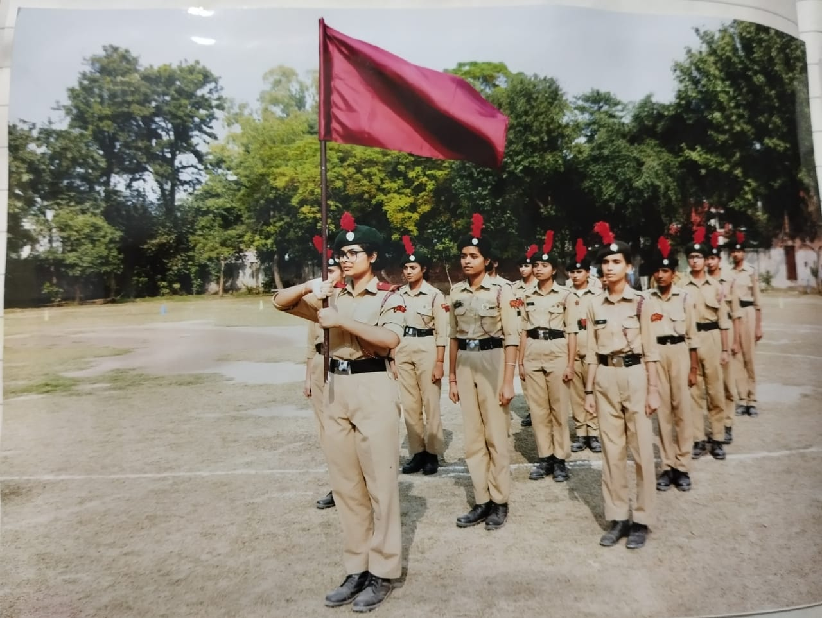

45. Date: 28.11.2023 NCC Day Celebration
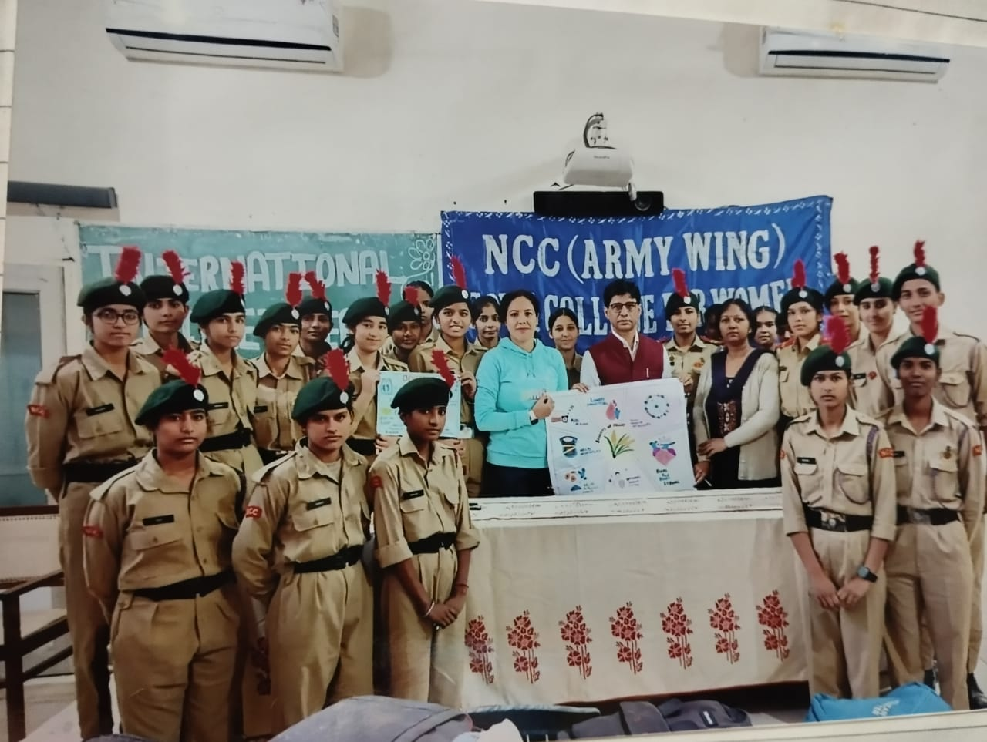
46. Date : 02.12.2023 Millet Day Celebration
